Table of Contents

Fully dressed use case: 36

Chapter 1: project proposal

**Introduction:**

Infinity boutique is an electronic trade framework which provides a user/client to visit an online store and shop different items that they desire. With the use of this system, users won't need to physically visit any boutiques or shops because they can have the things they want delivered right to their doorstep. Instead, they can choose from a variety of products at one simple platform.

**Executive summary:**

As we know the world is getting modern and is advancing day by day and the need for clothes and accessories is also increasing. Most people avoid going shopping as they have a busy schedule and are busy with their lives. To provide them with the facility to order what they want without leaving their house or their work, this electronic boutique system is a simple and easy way to access millions of different products without having to go and visit shops physically.

The project's goal was to give customers with all the available options and items on a single platform, reducing the need for them to physically visit different stores and saving them time and money that is spent on fuel wen going out for sopping. We are also aware of the hurdles that one must confront to obtain the products that truly suits them and what they actually desire. Instead of customers having to travel to the products, we thought, why not bring the things to them.

**Use Case Model:**

This system consists of the following actors

* Customer - Primary actor
* Visitor - Primary actor

* Admin - Secondary actor
* Salesperson - Secondary actor
* Bank - Secondary actor

The visitor can view or search products, but he/she must register an account to buy an item. The customer is a registered user of the system that will login to his/her account, search, or view items, add the desired items to the cart and can proceed to check out, make payment and give feedback about the items purchased. The customer will also be able to edit his/her shopping cart. The admin will also have to login to his account. He will manage account details, add, or update stock, and respond to customer feedback. The salesperson will login to his/her account and will add new stock to the boutique, view customer orders and confirm orders. The bank is responsible for authentication of bank account.

Chapter 2: use cases

**Diagram:**

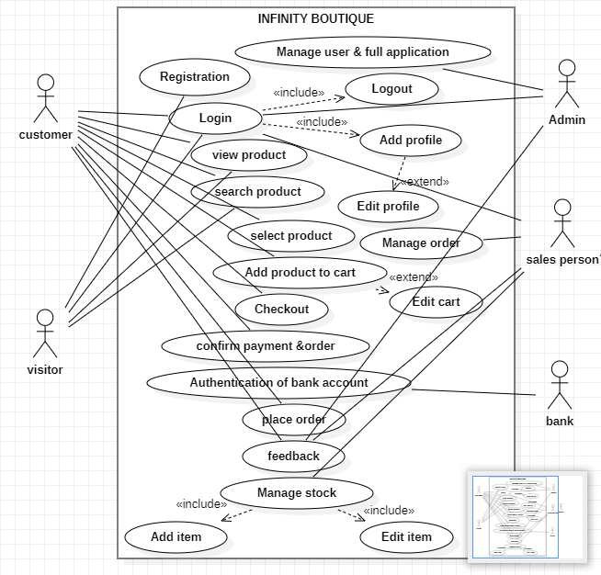

Aleeza Qadeer (SP21-BSE-033)

**Use case UC1: Registration Brief use case:**

In this use case user will get registered will the boutique if he/she is currently not a registered user. The user will be asked to choose a valid username and password in order to get registered. The user must be a registered user if he wants to make purchases.

**Fully dressed use case:**

|  |  |
| --- | --- |
| Use case name Registration | |
| Scope | Infinity boutique |
| Level | User goal |
| Primary actor | User |
| Stakeholder and interest | * Admin: Admin will have the notice of newly registered customer. The admin will have record of all the registered customer. * Salesperson: Salesperson will arrange the products according to the quantity of customer registered so that they don’t have to face shortage of supply. Salesperson will have order more stock as number of customers exceeds previous count. * Government tax agencies will collect charges from the website owner as the traffic of website increase. |
| Precondition | The customer must access the website with stable internet connection. |
| Success guarantee (post condition) | The customer after registering can log in to the boutique. |
| Main success scenario | 1. The salesperson and admin will have a notice when customer registers with boutique. 2. The admin will have to hire more salesperson if customer exceed certain range. 3. The salesperson will have to order more stock than usual to prevent shortage of stock in case or exceeding of customer. |
| Exception | * When the server is down due to some reason the customer could not get registered with the boutique. * The customer could not get registered if he has some network issues on his side. |
| Special requirements | If a customer enters login password of less than 8 digits, he/she will be asked to increase length of the password to get registered. |
| Frequency of occurrence | This will occur when the customer visits a website and want to create an account. |
| Miscellaneous | Is account is created on more than one email? |

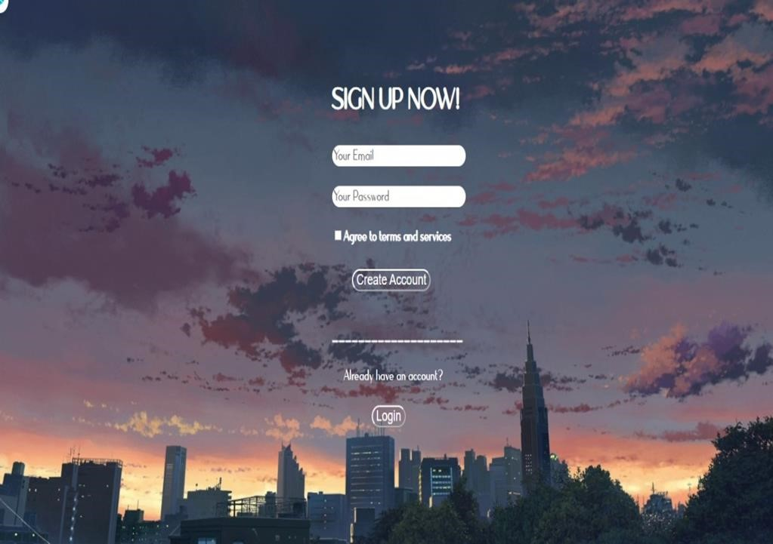

Aleeza Qadeer (SP21-BSE-033)

**Use case UC2: Login**

**Brief Use Case:**

In this use case the user will enter the boutique website. In order to use functionality of boutique the user must login first. After logging in to the website he can order stuff and make purchases.

The user has to use valid credentials to log in to the website.

**Fully dressed use case:**

|  |  |
| --- | --- |
| Use case name Log in | |
| Scope | Infinity boutique |
| Level | User goal |
| Primary actor | User |
| Stakeholder and interest | * Admin: Admin will have the record of how many customers visited website in specified time interval. * Salesperson: as a new customer login to the boutique, he will be provided with a salesperson. * Government tax agencies want to take tax from the boutique. |
| Precondition | The user to log in to the boutique must be registered in advance will the boutique |
| Success guarantee (post  condition) | After logging in the user can visit his/her desired area of interest. |
| Main success scenario | 1. The user will make purchases from the boutique. The user after making purchase will give his/her opinion regarding the boutique. 2. The admin on the other hand will take care about user’s interest and according to his/her feedback, necessary changes will be made. |
| Exception | The user is not able to log in to the boutique despite entering correct username and password. |
| Special  requirement | The user will have to write password exactly as he/she fixed it i.e. the password must me case sensitive. |
| Technology and  data variation list | The customer can choose forget password to change it again. |
| Frequency of occurrences | This will occur when the customer wants to get into the system. |
| Miscellaneous | What if the customer gets his password? |

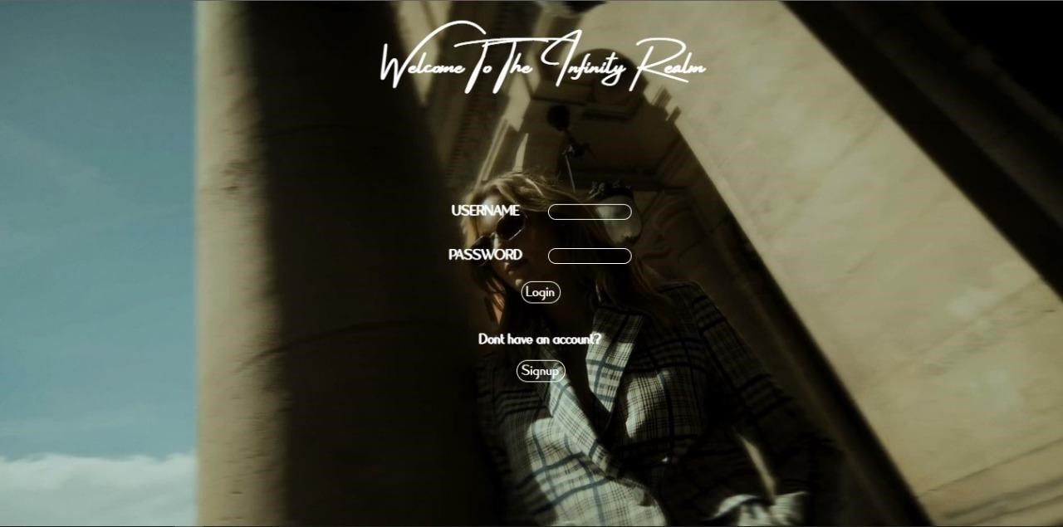

Eman Waheed (SP21-BSE-007)

**Use Case UC3: View Product**

**Brief Use Case:**

In this use case, both customers and visitors will be able to view the recommended product. They will be able to see every detail of the desired product, including its quality, usage instructions, and so on, by viewing it. Its detail may also include product price, category, and size if required.

**Fully dressed use case:**

|  |  |
| --- | --- |
| Use case name | View Product |
| Scope | Infinity boutique |
| Level | User goal |
| Primary actor | Customer, Visitor |
| Stakeholder and interest | * Visitor: want to view the product and must register if he/she wants to order it. * Customer: want to view the product of their choice and wants to know about the product details. |
| Precondition | * The user must visit the official website to view the product * The user must have a stable internet connection. |
| Success guarantee (post condition) | The user after viewing the product can add it to cart if they wish to order it. |
| Main success scenario | 1. The user will visit the official website. 2. The user will click on the product to view it. 3. The product details of the product will be visible to the user. |
| Exception | * If the user is not able to view the product, then he/she should refresh the page. * The user should be re-visiting the website. |
| Special requirements | If the product is not viewed, then the system will immediately show the message of refresh the page. |
| Technology and  Data variation list | • The name of the product should be entered by the keyboard.  • The programming language used is java. |
| Frequency of occurrence | This will occur multiple times as the user wants to view different products. |
| Miscellaneous | Can the customer directly view the products without visiting the official Website? |

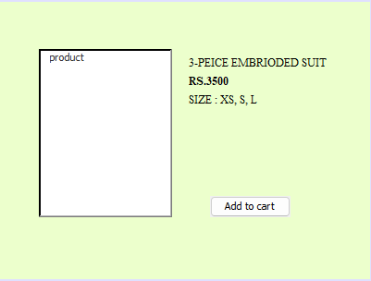

Eman Waheed (SP21-BSE-007)

**Use Case UC4: Search Product**

**Brief Use Case:**

If the user can't find their desired product on the main page, they can click on the search panel and search for the specific product that they desire. This use case helps them to find the product of their choice.

**Fully dressed use case:**

|  |  |
| --- | --- |
| Use case name | Search Product |
| Scope | Infinity boutique |
| Level | User goal |
| Primary actor | Customer, Visitor |
| Stakeholder and interest | * Visitor: want to search the product in the infinity boutique system. * Customer: want to search the product in the infinity boutique system. |
| Precondition | * The user must visit the official website to search the product * The user must have a stable internet connection. |
| Success guarantee (post condition) | The user can view the desired searched product. The user can add the product to the cart. |
| Main success scenario | 1. The user will visit the official website. 2. The user will click on the search bar. 3. The user will search for the product of their choice. 4. The user can view the product |
| Exception | *A. At any time when the search bar is not proper functioning:  • The user will find the product from the categories. |
| Special requirement | It should take less than 10 characters.  Both upper and lower-case characters can be used. There should be no numerical value. |

|  |  |
| --- | --- |
| Technology and  data variation  list | * The name of the product should be entered by the keyboard. * The programming language used is java. |
| Frequency of  occurrence | • It will be continuous as multiple users will be searching for different products. |
| Miscellaneous | Can users search for the product by its bar code or just by its name? Is the search bar functional or not. |

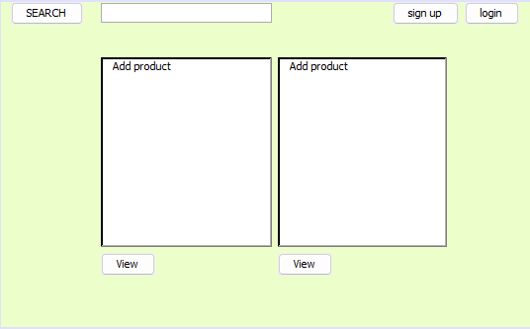

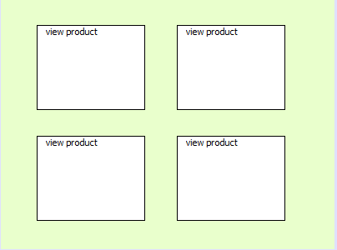

Bushra Gul (SP21-BSE-070)

**Use case UC5: Add Product to Cart**

**Brief use case:**

All the product of customer interest will be assembled in the cart .it will collect all product of customer interest at here to make sure only this item is going to be shipped and confirm. After all products assemble there will be total amount of the customer, he is going to pay for generated.

**Fully Dressed Use Case:**

|  |  |
| --- | --- |
| Use Case Section Comments | |
| Use Case Name | Add product to Cart |
| Scope | Infinity Boutique |
| Level | User goal |
| Primary Actor | Customer |
| Stakeholders and Interests | Customer:  All products are selected and assembled in the cart by customer. |
| Preconditions | * Product must be selected by customer * Customer must be registered * Customer account must be verified. |
| Success Guarantee | * As products selection is completed press done * Once done is pressed total amount will be generated of selected items. * Proceed Button will be pressed by customer for further processing. |
| Main success scenarios | * As items selected by customer * These selected items will be moved to cart * After selection is done * Total amount will be calculated beneath products * proceed is pressed by customer for moving ahead |
| Exceptions | * If items are missed to be entered in cart move toward edit * if product total failed to calculate then select again to be shown |
| Special  Requirements | * There will be a feature to change the product * An edit a product if customer wants * There will be check out option if customer wants to confirm his/her cart |
| Technology and Data variations List | Post code of each product will be shown along every item in cart. |
| Frequency of Occurrences | * It will occur only one time per order. * Always occur before order a product. |

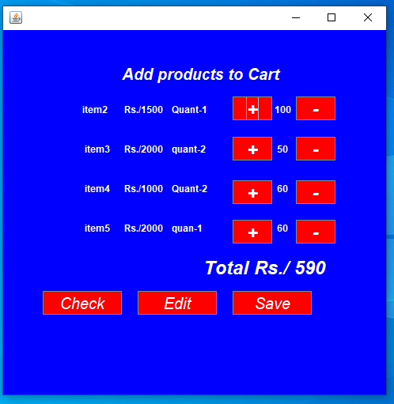

Bushra Gul (SP21-BSE-070)

**Use Case UC6: Checkout Cart**

**Brief use case:**

It will appear as customer clicked check out to make sure what was selected and what was the total money generated and if something (product) need to be changed customer can do per record in check out and went wrong he/she can change the product or edit the product.

**Fully dressed use case:**

|  |  |
| --- | --- |
| Use Case Section Comments | |
| Use Case Name | Check Out cart |
| Scope | Infinity Boutique |
| Level | User goal |
| Primary Actor | Customer |
| Stakeholders and Interests | Customer:  He/she wants to confirm his/her items that must be shipped. |
| Preconditions | * List must be completed * Proceed must be pressed by customer. * A list is already available. * Amount must calculate and appeared beneath. |
| Success Guarantee | As customer checked and confirmed then confirmation will be done to have pressed confirmed button by customer. |
| Main success  scenarios | 1. After add product to cart is done 2. Customer can go with check out option if he/she wants. |
| Exceptions | If list does not complete or some selected item is missed, then add product to cart button will be appear to give one more chance to select item again. |
| Special  Requirements | * There will be an option to click check out again. * There will be an option to click edit product. |
| Technology and  Data variations List | There will be post cost of every product available. |
| Frequency of Occurrences | * It will appear as customer pressed check out button. * Only once per clicked check out * Not always occur |
| Miscellaneous | How many customers checkout the cart at a time? | |

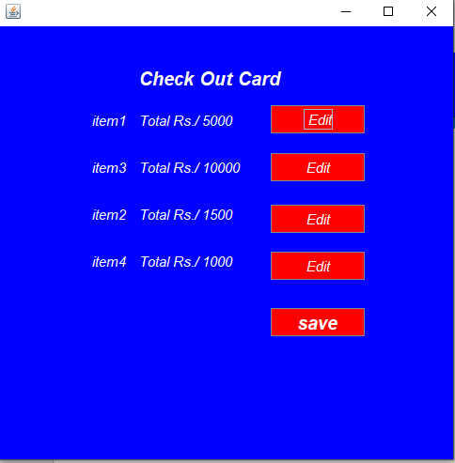

Esha Tahir (SP21-BSE-008)

**Use case UC7: Place Order**

**Brief use case:**

The customer can edit his cart before placing the order. When the customer proceeds to checkout, he enters his personal information and selects an appropriate payment method. After that, he has to click on place order in order to confirm his order.

**Fully dressed use case:**

|  |  |
| --- | --- |
| Use case name | Place Order |
| Scope | Infinity boutique |
| Level | User goal |
| Primary actor | Customer |
| Stakeholder and interest | Customer: wants to buy the selected product. |
| Precondition | * If the customer wants to buy multiple items, he must add selected items to the cart. * The customer proceeds to checkout and enters his personal details. * The customer must select a valid payment method. |
| Success guarantee (post condition) | The customer will get an order confirmation message. |
| Main success scenario | .   1. The customer finds the required item and adds it to the shopping cart. 2. The customer can edit his cart if he wants to add or remove a product. 3. The customer proceeds to checkout. 4. The customer must enter his details and shipping address. 5. The customer selects a payment method. 6. The customer clicks on place order to confirm the order. |
| Exception | At any time when a selected product is already sold out and the system fails to place the order:  • The customer will have to choose another item. |
| Special requirement | * The customer must have a stable internet connection. * The customer must have entered his valid details. |

|  |  |
| --- | --- |
| Technology and  data variation  list | The customer clicks on place order and an order confirmation message appears on the screen. |
| Frequency of  occurrence | • It will occur when the customer places an order. |
| Miscellaneous | Can a customer place multiple order? |

Esha Tahir (SP21-BSE-008)

**Use case UC8: Feedback**

**Brief use case:**

Customers gives feedback about the products bought from a specific boutique. They can share their experience about the products. Customers give feedback in two ways by comment and by rating. Admin view their feedback and give response on these feedbacks.

**Fully addressed use case:**

|  |  |
| --- | --- |
| Use case name Feedback | |
| Scope | Infinity boutique |
| Level | User goal |
| Primary actor | Admin, User |
| Stakeholder  and interest | * Admin: wants to know how many customers are giving feedback. * Customer: Give feedback on the quality and quantity of products. |
| Precondition | Customer can give feedback after buying the product. |
| Success guarantee (post condition) | Admin View/ check the feedback. |
| Main success scenario | 1. The Customer give the feedback but first he will purchase the item from the boutique. 2. Admin view the customer’s Feedback. And take steps according to the feedbacks |
| Exception | When customer add feedback, but system can’t show their feedback the admin resolves this issue. | |
| Special  requirement | If the customer wants to give feedback, then it will immediately do without taking any time. | |
| Technology and  data variation  list | When customer give the feedback then system will show the message of “Thanks your feedback”. | |
| Frequency of  occurrence | This will occur when customer want to give feedback. | |
| Miscellaneous | How many customers give feedback? | |

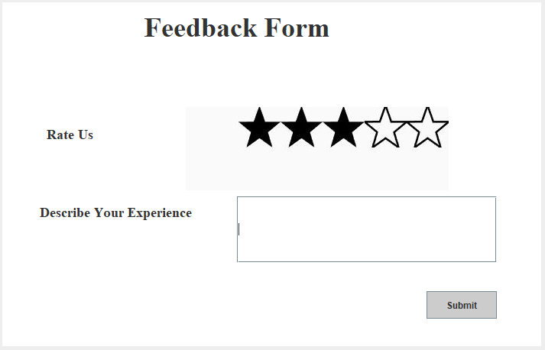

Hira Akram (SP21-BSE-011)

**Use case UC9: Confirm Payment and Order**

**Brief Use Case:**

This use case is related to the payments for the product. When user views their cart they can view the price of all the items /she selected for purchasing. Slip of their selected items with price will be displayed on the screen. In this slip information of customer’s order is given. Information about their selected items like item name, color description quantity price etc. are given in this slip. A registered user (Customer) can only purchase the items if user is not registered then they fill the registration form and then they can easily purchase the items. Customers enter their address for shipment and confirm their address, order and payment. When customer confirm payment and order then methods of payment were displayed on the screen. Payment can be done through Online process. Customer can pay through easy paisa or Debit card. Customer can choose only one method for payment.

**Fully Dressed Use Case:**

|  |  |
| --- | --- |
| Use case Section | Comments |
| Use Case Name | Confirm Payment and order |
| Scope | Infinity Boutique |
| level | User Goal |
| Primary Actor | Customer |
| Stakeholder and interest | * Customer: Wants to purchase the items. * Visitor: If visitor wants to purchase the items firstly they fill the registration form after this they can view the cart and confirm their payment and order. * Bank: The Payment submits in the bank. * Sales Person: When customer confirm their orders and payment the sales person manage all these orders. |
| Precondition | * Customer must be register with the system. * Customer must be add their items to the cart which they want to buy. |
| Success guarantee (post condition) | After the selection of payment method customer enter their bank account information then verification of their account will be done. |
| Main success scenario | 1. Customer view the cart if they buy this product they can check all the information of their order and also add their address for shipment. The information of all the items which they selected are given in the cart. The total price of their order is aloso be given.If Customer buy these items they confirm the order and payment. 2. Payment can be done through online process. 3. Payment can be done through easypaisa or debit card. Customer can select one method for payment. 4. Only registered user can purchase the items 5. Customer give their shipment address and confirm their order and payment. |
| Exception | * If the Customer confirm their order and payment but still the system doesn’t shows the payment methods, then the admin fix this problem. * If customer add their shipment address and this Address is not added then the admin fix this problem. * If customer select payment method but system shows that they can’t select the payment method then admin fix this problem. |
| Special requirement | **Performance:** When Customer add their address and confirm their order and payment the system quickly confirm their address order and payment also display the payment methods within in a seconds. |
| Technology and data variation list | * The Address for shipment should be added by keyboard. * “Confirm payment and order “action done by clicking on the button by mouse. * The methods for payment should be selected by clicking on the button by mouse. * The Programming language is used is java. * The interface is designed using NetBeans. * The Use Case diagram is designed by using Star UML. |
| Frequency of occurrence | It will be continuous as multiple users will be Confirming order and payment. |
| Miscellaneous | * How many payments made by customer at a time? * How many Address for shippment add by user at a time? * Can customer make the payment without registration? |

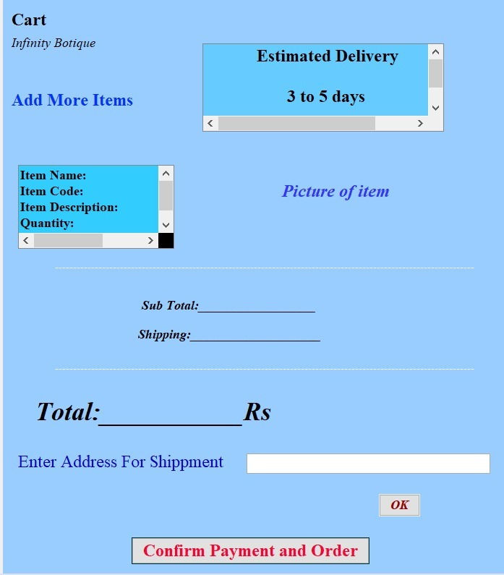

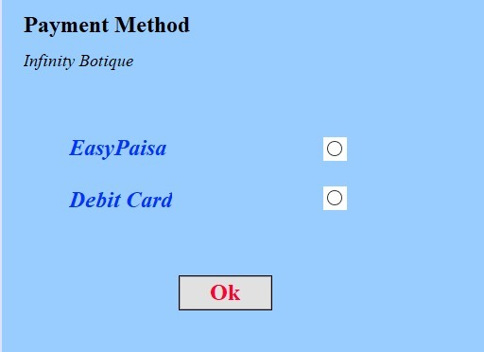

Hira Akram (SP21-BSE-011)

**Use case UC10: Authentication of bank account**

**Brief Use Case:**

In this use case the customer enter information of their account ,fill the form of payment . The bank is responsible to check the customer account number if there given information is valid then system request for the pin of account if pin is valid then bank check the balance in the customer account . Then bank deduct the amount from the customer account according to the payment slip and give the command to the system that payment has been done successfully and system generate the message to the user that “Thank you! Your payment has been done successfully”. If there is no amount in the customer account then bank send message to the system “Payment Transaction failed due to insufficient balance” and system display the message to the customer “Dear Customer! Payment Transaction failed due to insufficient balance”. If account of customer does not exsist then bank send message to the admin that “There is something issue with this account number” and admin send this message to the customer.

**Fully dressed use case:**

|  |  |
| --- | --- |
| Use Case Section | Comments |
| Use Case Name | Authentication of Bank Account |
| Scope | Infinity boutique |
| Level | User goal |
| Primary actor | Bank |
| Stakeholder and interest | Admin: wants to check all the payment history of orders.  Salesperson: wants to check how many products are sale in per day by payment history.  Customer: wants to check their payment history of their orders.  Government tax agencies: wants to take tax from the admin. |
| Precondition | The Customer Select the payment method. |
| Success guarantee (post condition) | After payment, the message of payment will be given to the customer. |
| Main success scenario | * Customer enter information about their account. * Bank checks the information about their account if there information is valid then system request for pin. * Customer Enter pin. * Bank check their pin if their pin is valid then Bank check the balance in the customer’s account and deduct the amount according the bill. * If transaction done successfully then system show the message to the customer that “Thanks! Your transaction has been done successfully”. Other wise System show the message of “there is something went wrong. |
| Exception | The system will not give the confirmation message of payment to the customer as there are some errors during making payment. |
| Special requirement | **Performance:** When Customer enter their account information and pin the system will give quickly response to the system within in minute. |
| Technology and data variation list | * The information of bank account should be added by keyboard. * “Done “action during the entering of account information done by clicking on the button by mouse. * The PIN of Account should be entered by keyboard. * The action of “Submit” the pin is done by clicking on the button by mouse. * The Programming language is used is java. * The interface is designed using NetBeans. * The Use Case diagram is designed by using Star UML. |
| Frequency of occurrence | It will be continuous as multiple users will be entering bank account information and PIN. |
| Miscellaneous | Can Customer make the payment by both methods? |

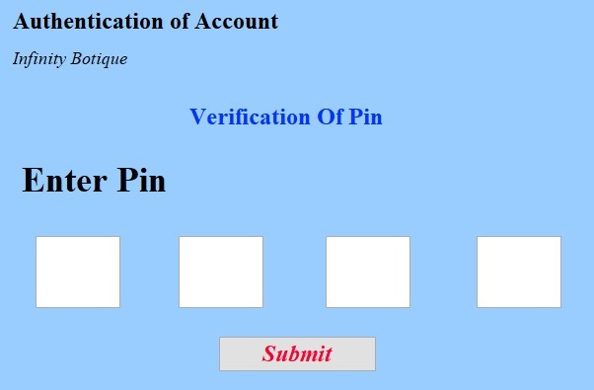

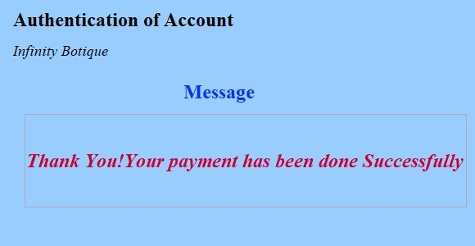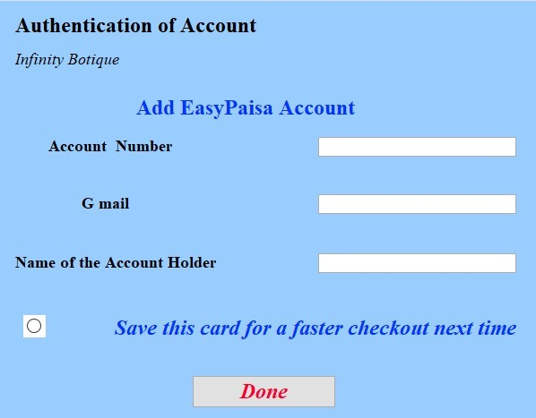

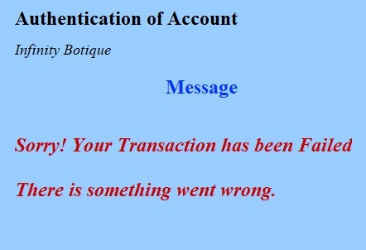

Syed Faizan Haider (SP21-BSE-001)

**Use case UC11: Manage Users and Full Application**

**Brief use case:**

In this use case the Admin/Manager is dealing with all the accounts that are registered on the system. The admin can view status of active/inactive users and can also activate or deactivate their accounts moreover the admin can also delete or remove User accounts if they want to, this will help protect the system against scammers and suspicious accounts and help maintain a scam free environment.

**Fully Dressed use case:**

|  |  |
| --- | --- |
| Use case name | Manage user and full applications |
| Scope | Infinity boutique |
| Level | User goal |
| Primary actor | Admin |
| Stakeholder and interest | * Admin: wants to manage the Users so that there are only valid/authentic people that are registered on the system, by doing so the admin can keep track of all the people that are registered and have verified their profile. This will help avoid getting scammed and prevent other malicious activities. |
| Precondition | The person has to login as admin in order to confirm their role as the admin. |
| Success guarantee (post condition) | Login is successful and the admin is verified and authenticated. All the features that are only visible to admin are unlocked. |
| Main success scenario | 1. The admin will have the information of all the users that are registered on their system. 2. The admin can disable/enable user accounts. 3. The admin will also delete some accounts that he/she finds suspicious. |
| Exception | * If the login credentials are incorrect and someone is trying to access the system as admin, the admin will be notified. * If a user has been deleted but they are still visible and still have access to the system, the admin has to fix this bug. * If someone’s account is dis-abled they will receive a message saying “Account Disabled”. |
| Special requirement | In order to unlock all the features that are visible to admin only. One must provide all details that are required to login as an admin. |
| Technology and data variation list |  |
| Frequency of occurrence | This will occur whenever the admin wants to check and manage users on their site/system. |
| Miscellaneous | How many new users have registered?  How many of the registered accounts are active users and not bots? |

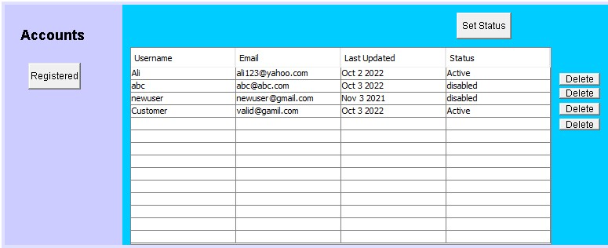

Syed Faizan Haider (SP21-BSE-001)

**Use case UC12: Manage customer order**

**Brief use case:**

In this salesperson is responsible to view the customer order which is placed by customer and if the order is confirmed and authentic the admin/the salesperson is responsible to check the status whether it is on hold or is being shipped.

**Fully Dressed use case:**

|  |  |
| --- | --- |
| Use case name | Manage customer order |
| Scope | Infinity boutique |
| Level | User goal |
| Primary actor | Admin |
| Stakeholder and interest | Admin views customer order in which customer select the product and product quantity So according to selection of product and quantity generates bill which is paid by customer |
| Precondition | There must be an order placed by a customer only then the salesperson view customer order |
| Success guarantee (post condition) | After confirming the customer order product is shipped. |
| Main success scenario | Order must be placed if the order is placed then the salesperson/admin can view the order and proceed to other processes for instance, start shipping of the product |
| Exception | If the customer’s order is not viewed by the admin/salesperson due to any reason then it may be skipped and shipping of all other orders next to it may start. |
| Special requirement | Once the order will be viewed and confirmed then the shipping process will start. |
| Technology and data variation list |  |
| Frequency of occurrence | This will occur when salesperson wants to view the customer order. |
| Miscellaneous | Which order is viewed by salesperson/admin? |

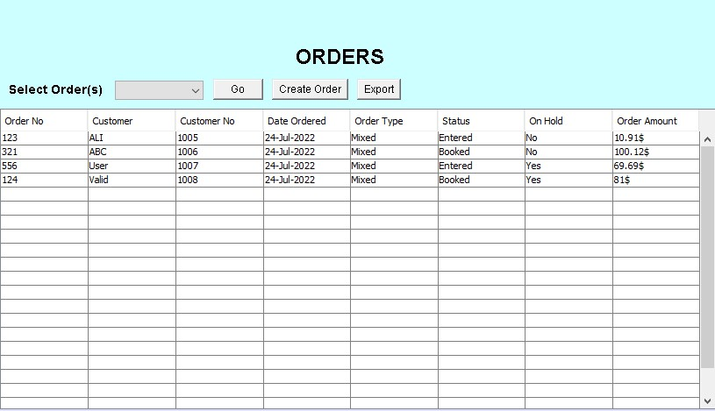

Omiya Jadoon (SP21-BSE-021)

**Use case UC13: Manage stock**

**Brief use case:**

In this use case the admin is responsible for the stock management. The admin manages the stock information and the status, the sales information and the status, the products information and the status and keeps the record of the previous stock. In this use case the admin will also add the products from the stock that are near to end so that the customers don’t wait for the products to be purchased. The admin can also update the stock means if there are new products then he can also add them to the stock. He can also delete the products that are no longer purchased by the customers.

**Fully addressed use case:**

|  |  |
| --- | --- |
| Use case name | Add stock |
| Scope | Infinity boutique |
| Level | User goal |
| Primary actor | Admin |
| Stakeholder and interest | * Admin: wants to manage the stock so that when the products are near to end then he must have the enough stock of that products and he just only add those products so that the customers don’t wait and then refill the stock again as per sale of the products and update and delete the stock products if needed. * Salesperson: wants to have enough products in the stock so that whenever customers demand for the product then the salesperson fulfils the customers demand without having to ask customers to wait until stock fulfilled. * Customer: wants to purchase the product on time and do not wait for the product to be fulfilled in the stock and then purchase. * Government tax agencies wants to collect the tax from the admin when he will buy the stock. |
| Precondition | The products must be near to end or there are some new products so that the admin will buy those products and add them to the stock. |
| Success guarantee (post condition) | Stock is successfully added so the whenever customers want to buy the desired products then they will not wait. |
| Main success scenario | 1. The admin will have the information of the product sales per week. 2. The admin will add the products in the stock as per their sales. 3. The admin will also update the products in the stock if new products are available. 4. The admin can also delete the products that are no longer purchased by the customers. |
| Exception | * When the product is not added due to some reason then the customers will see that the product is out of stock. * If the product is added successfully but still the system shows that the product is out of stock, then the admin fixed this problem. * If the product is out of stock and system does not show that product is out of stock, then the admin also fixed this issue. |
| Special requirement | If the product is not available in stock, then the system will immediately show the message that the product is out of stock. |
| Technology and data variation list |  |
| Frequency of occurrence | This will occur when the products are near to end, or new products are available, and the admin will add the products from stock. |
| Miscellaneous | How much stock of different products are needed?  How many new products are available that are needed to be add? |

Aiman Sajjad (SP21-BSE-038)

**Use case UC14: Select Product**

**Brief use case:**

First customer search the product then select the product after selection customer cart the products. After this he has an two option (checkout, view cart) if customer wants to direct checkout then he choose the option of checkout or if he want to view about cart then he simply click on the view cart button.

## Fully dressed use case:

|  |  |
| --- | --- |
| Use case name | Infinity boutique |
| level | User goal |
| Primary actor | customer |
| Stakeholder  And interest | Customer wants to buy their own choice of product |
| precondition | Customer should register their self |
| Success guarantee(post condition) | Customer should cart the selected product for checkout |
| Main success scenario | * Customer finds their own choice of product and can be selected * Customer cart their selected product * Customer checkout the cart after product selection |
| exception | If customer doesn’t make an account or does not register their self the he will not select the product then system will show message if you want to select their own choice of product please make their account |
| Special requirement | If page is stuck and products are not selected please refresh their page or secondly again login the website |
| Technology and data variation | If visitor wants to select the product then system will simply show ,message please login their account if you are interested to buy our products |
| Frequency of occurrence | It will occur when customer select the product |
| miscellaneous | Can a customer selects multiple orders |